PRE – REQUISITES

|  |  |
| --- | --- |
| Date | 04 November 2022 |
| Team ID | PNT2022TMID27179 |
| Project Name | Smart farmer -IOT enabled smart farming application |

IBM CLOUD SERVICES

IBM LOGIN

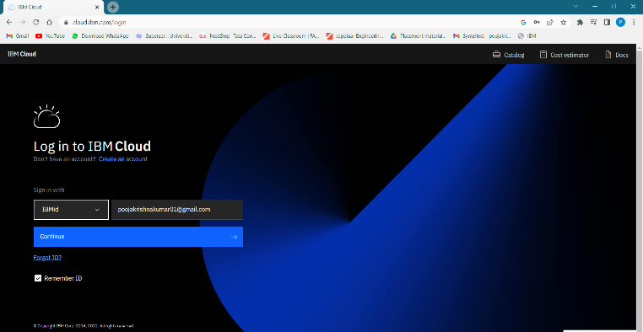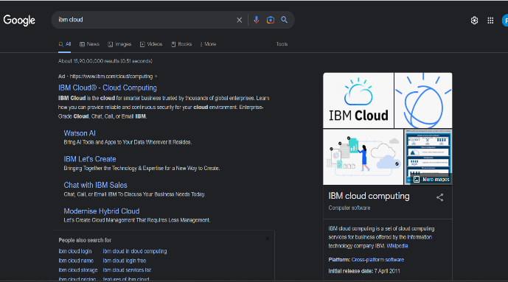

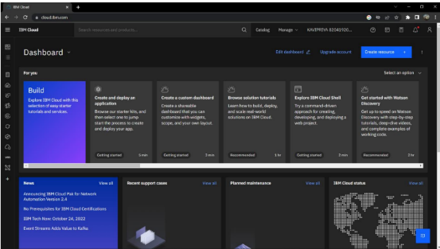 IBM Account Dashboard

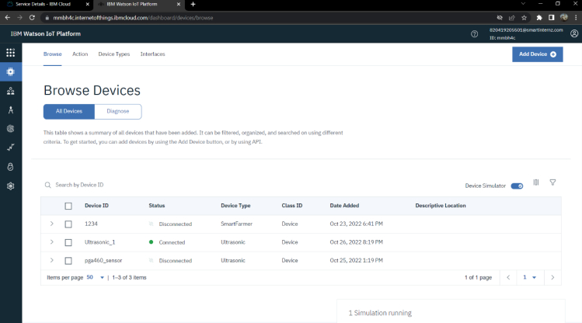

**IBM Watson IoT Platform**